Bradley Lamitie Active Learning 2

**Description**:

The main intent of this active learning module is to solidify our understanding of how to configure a small network with both static routing and using RIP. This is achieved through repeating the steps we followed in class to configure an identical network in Cisco Packet Tracer.

**Topology**:

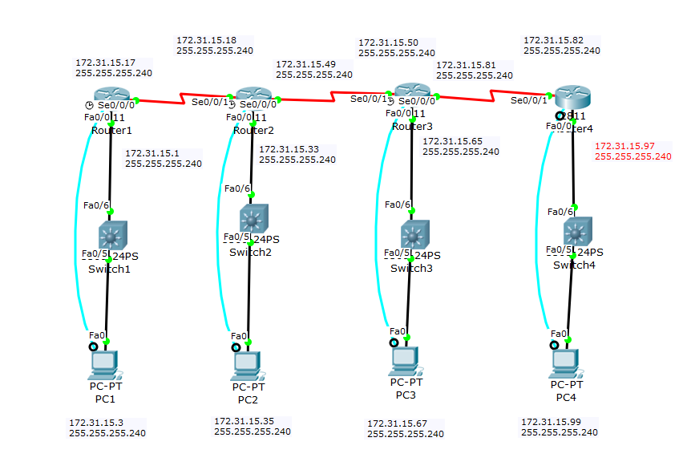

**Configuration Syntax:**

(All replaceable parameters are in italics)

|  |  |  |
| --- | --- | --- |
| **Syntax** | **Description (in my own words)** | **Mode** |
| enable | Enter privileged mode | user |
| config | Enter configuration mode | privileged |
| terminal | Configures from terminal | privileged |
| Hostname *desiredHostName* | Renames the router | Global configuration |
| Enable password *cisco* | Sets the privilege mode password to be ‘cisco’ | Global configuration |
| Ctrl + Z | Returns to privileged mode | Global configuration |
| Logging synchronous | Makes it so that the console does not create messages while you're typing a new command | Interface configuration |
| Line con *0* | Enters configuration mode for console line 0 | Global configuration |
| Password *cisco* | Sets the console line password to be ‘cisco’ | Interface configuration |
| login | Makes logging in required when accessing router from pc through console | Interface configuration |
| Interface *f0/0* | Sets the configuration mode to configure fast ethernet 0/0 port. | Global configuration |
| Ip address *ipAddress* *SubnetMask* | Configures the ip address and subnet mask for the specified interface | Interface configuration |
| No shutdown | Enables the interface | Interface configuration |
| Int *S0/0/0* | Sets the configuration mode to configure Serial slot 0/0/0 | Global configuration |
| Clock rate *64000* | Sets the clockrate of the DCE interface to be 64000 | Interface configuration |
| Show interfaces | Shows the interfaces and their stati | privileged |
| Show ip route | Shows the ip routing table | privileged |
| exit | Exits configuration mode | any |
| disable | Leaves privileged mode | Any mode above user |
| Ip route *networkAddress* *SubnetMask* *ClosestUsableIPAddress* | Creates a route in the routers routing table | Global configuration |
| Line vty 0 4 | Selects the first 5 virtual terminal lines | Global configuration |
| Copy running-config startup-config | Copys the running configuration to a file that runs on startup. | Global configuration |
| Router rip | Sets the router to use RIP | Global configuration |
| Version 2 | Sets the version of rip to version 2 | Router Configuration |
| Network *classical address* | Sets the network to use with RIP | Router Configuration |
| Show ip protocol | Shows information about the current protocol on your router | privileged |
| No Ip route *networkAddress* *SubnetMask* *ClosestUsableIPAddress* | Gets rid of a static route in the routing table | Global configuration |
| Show ip int brief | Displays interfaces in a shorter format than show interfaces. | privileged |

2b)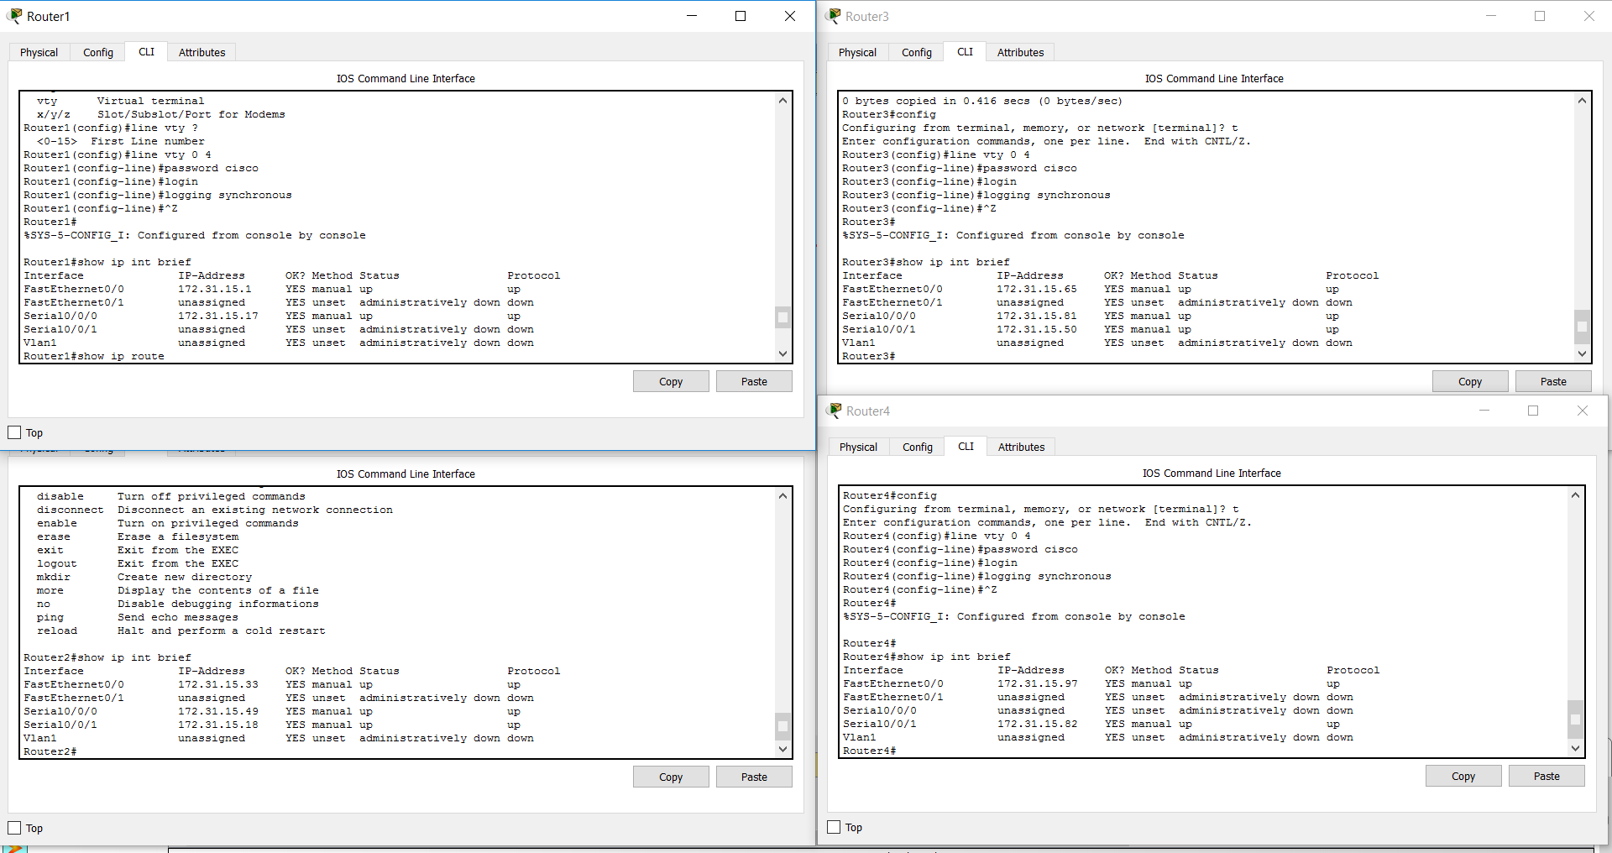

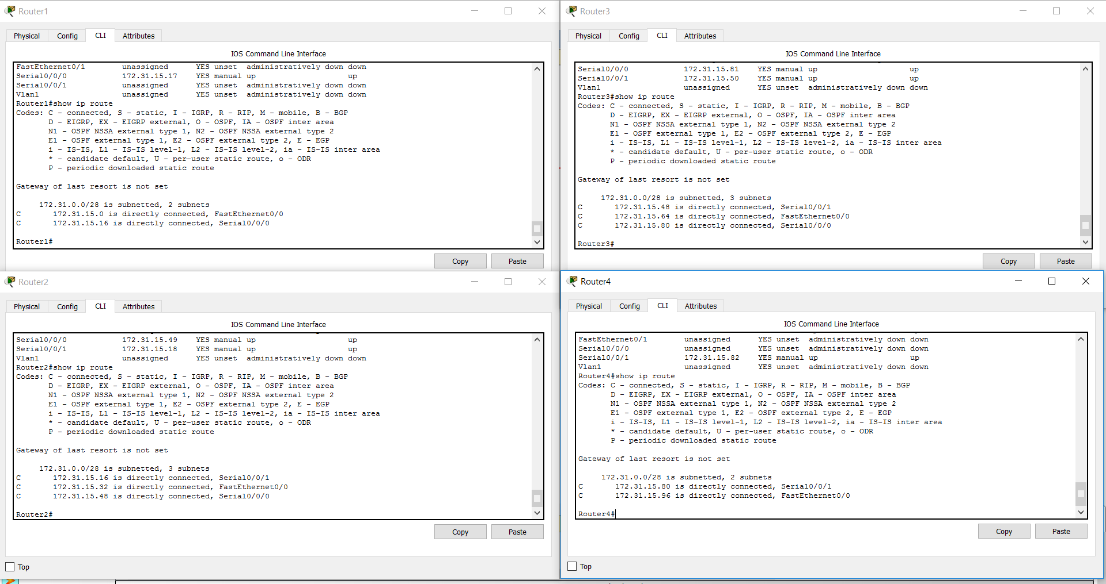

**2c)**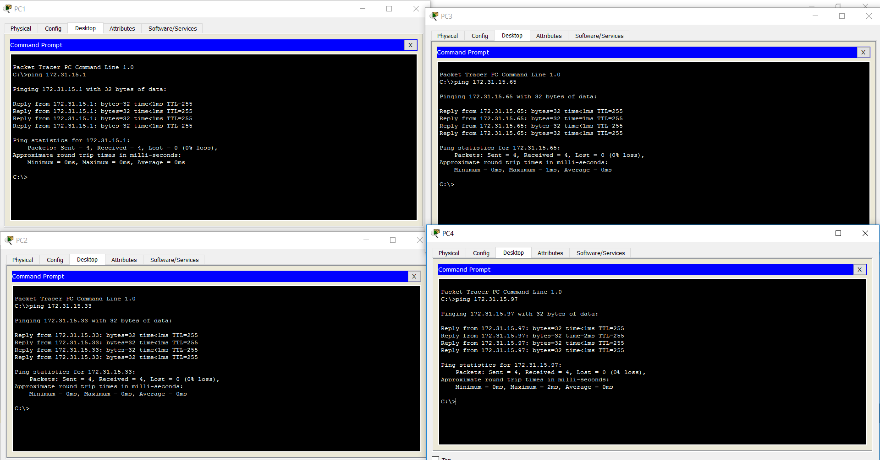

**2g)**

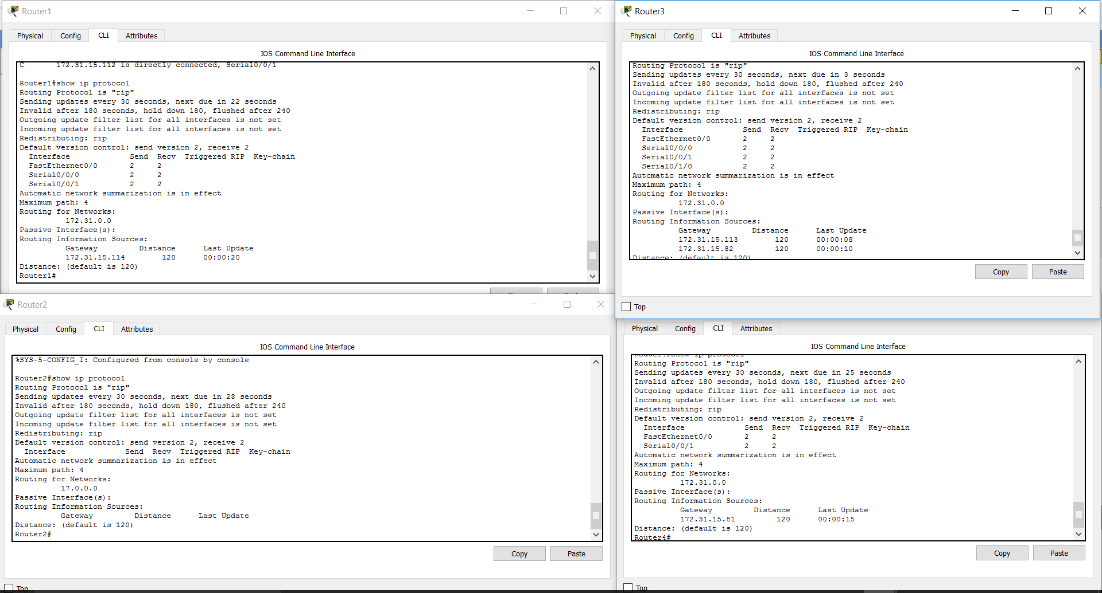

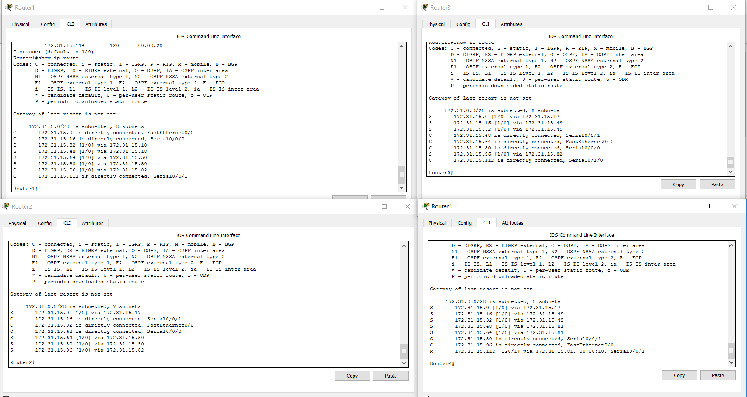

**2h)**

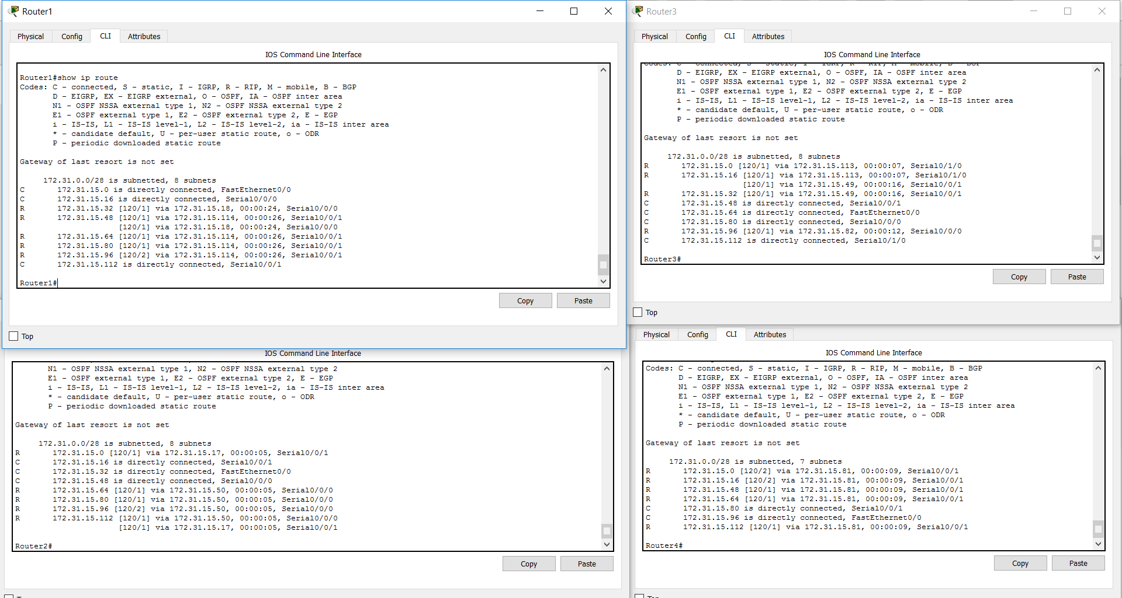

**Troubleshooting Syntax:**

I didn't have any problems this time.

**What Worked, What Didn’t?:**

Everything worked fine.